**Static Code analysis hands-on**

**Instruction:**

**In all assignments, as part of fixing the reported issues, add comments in the code spacifying change details above code changes and share the final solutions.**

**Getting Started**

**1. Login into the Linux server**

**2. Create a new directory called splint in your home directory <home>**

**mkdir splint**

**3. Go inside the directory you have created in (2) /<home>/splint**

**cd splint**

**4. Copy the following files from the path as mentioned by the trainer:**

**a. sample1.c**

**b. sample2.c**

**c. sample3.c**

**d. sample4.c**

**e. sample5.c**

**f. sample6.c**

**Static Code analysis using Splint**

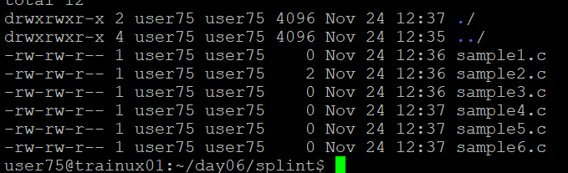

**5. Read through the code for sample1.c and statically check the file**

**splint sample1.c**

**Closely analyze the warnings given by Splint. Some of the warnings given by a static code analyzer may not be valid for your code.**

**E.g. suppose in this example you do not want the warnings related to unused parameters and variables. Try giving the splint command with –paramuse and –varuse to inhibit these warnings:**

**splint –paramuse –varuse sample1.c**

**6. Read through the code for sample2.c and statically check the file**

**splint sample2.c**

**Edit this file to fix all the warnings and re-run splint on the updated program**

**7. Read through the code for sample3.c and statically check the file**

**splint sample3.c**

**Edit this file to fix all the warnings and re-run splint on the updated program**

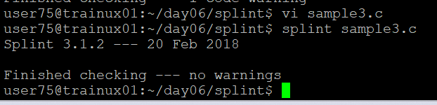

**8. Read through the code for sample4.c and statically check the file**

**splint sample4.c**

**Edit this file to fix all the warnings and re-run splint on the updated program**

**9. Read through the code for sample5.c and statically check the file**

**splint sample5.c**

**Edit this file to fix all the warnings and re-run splint on the updated program**

**10. Read through the code for sample6.c and statically check the file**

**splint sample6.c**

**Edit this file to fix all the warnings and re-run splint on the updated program**

**Including Static Code analysis as part of the makefile**

**11. Copy the files below to your working directory (which were used in makefile assignment). Create the project directory structure and copy them to appropriate directory. Add a makefile in make directory to include options to run splint tool on files program.c, simplelink.c. Fix the issues reported.**

**a. program.c**

**b. simplelink.h**

**c. simplelink.c**

**[You may reuse the makefile created earlier and edit to include splint static analysis]**

